Sprint 2 Report

Plannertarium, by Team Scrumbags, 11/5/2023

# Actions to stop doing

The team should stop Scrum meetings because the rest of the team needs to know how far each member is in their work to plan accordingly. The team should stop overestimating how long it takes to complete an ideal hour because we are always behind on work even though we all put in many hours. The team should stop implementing only part of a user story because it does not follow Agile and Scrum, and we have not delivered enough functionality.

# Actions to start doing

The team should start spending more time planning before the next sprint because we have been consistently confused about Scrum practices and had to redo some documents. The team should start leaving both positive and negative feedback in reviews because it would be more helpful to the developer to know more about what they are doing well and what they can improve. The team should start having a better understanding of Scrum practices because we spent a lot of time confused about how to write a required document and redid them many times.

# Actions to keep doing

Reviewing pull requests is working well because we can find issues in each other’s code and stay updated on each other’s work at the same time. Frequent online communication is working well because we quickly resolve issues that come up when one person is using another person’s work and something goes wrong.

# Work Completed/Not completed

Completed tasks and stories are crossed out

1. See my inputted information when I reopen the app so that I do not need to keep it open - 13pt - 6hrs
   1. ~~Support Google SSO - 2hr~~
   2. Handle Google SSO errors and integrate Google username into database - 2hr
   3. ~~Create methods to read user data from the database into memory upon app launch - 2hr~~
2. ~~Create tasks so I can add tasks to my schedule - 2pt - 1hr~~
   1. ~~Create methods that save a task object to the database - 1hr~~
3. Click on tasks to see more information about them - 3hr
   1. Create a new Widget on the UI to accept new tasks - 1hr
   2. Display tasks in daily any view - 2hr
   3. Display tasks in weekly view – 0hr
   4. Display tasks in monthly view - 0hr
   5. Link the UI Widget to the new method - 0hr
4. ~~Change properties of a task so that I can mark them as completed, move to another date, etc - 2pt - 1hr~~
   1. ~~Add getters and setters to Task class to update their attributes - 1hr~~
5. Task gestures so that I can move them around the timeline as necessary - 5pt - 2hr
   1. Add UI for swipe left on a task Widget - 2hr
   2. Add UI for swipe right on a task Widget - 0hr
   3. Add UI for double tap on a task Widget - 0hr
   4. Add UI for holding down on a task Widget - 0hr
   5. Add UI for moving tasks to different times on the timeline - 0hr
6. ~~Create events so that I can add new events to my schedule - 1pt - 1hr~~
   1. ~~Create methods that save an event object to the database - 1hr~~
7. Click on events so that I can see more information about them - 8pt - 2hr
   1. Create a new Widget on the UI to create new events - 0hr
   2. Display events in daily view - 2hr
   3. Display events in weekly view - 0hr
   4. Display events in monthly view - 0hr
   5. Link the UI Widget to the new method - 0hr
8. ~~Change properties of an event so that I can change details about location/time/etc - 8pt - 4hr~~
   1. ~~Add getters and setters to Event class to update their attributes - 1hr~~
   2. ~~Create recurrence functions to set an event as recurring - 2hr~~
   3. ~~Support infinite recurrence - 1hr~~
9. Click on properties of an event so that I can see more detail - 2pt - 1hr
   1. Add UI for seeing event and moving back to different times on the timeline - 1hr
10. Switch between time windows so that I can plan for the short, medium and long term as needed - 8pt-2hr
    1. ~~build the screen for the daily/weekly view - 1hr~~
    2. Build the screen for the monthly view - 0hr
    3. Add UI buttons and swipe gestures to change time windows - 1hr

# Work Completion Rate

average user stories/day and average ideal work hours/day figures computed across all sprints to date.

Total number of user of stories completed during the prior sprint: 3

Total number of estimated ideal work hours completed during the prior sprint: 9 hours

Total number of days during the prior sprint: 14 days

User Stories/day = 3/14 = .214 stories/day

Average user stories/day = avg(0, .214) = .107 stories/day

Ideal hours/day = 9/14 = .643 ideal hours/day

average ideal hours/day = avg(.571, .643) = .607 ideal hours/day

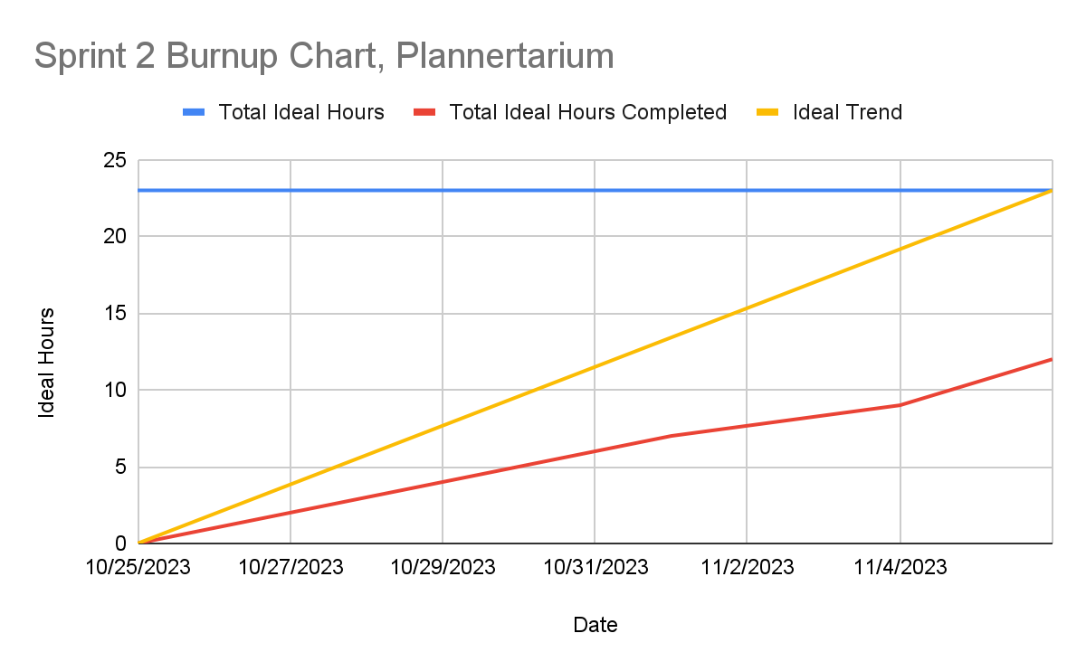

Although the burnup chart shows we are not as far behind as with the last sprint, we were still trailing fairly far behind the ideal trend. We believed that because we were now more experienced and had infrastructure, we could get significantly more done this sprint. However, we still drastically underestimated our ability compared to an ideal hour, and found that one ideal hour might translate into over 5 actual hours despite our improved knowledge. We will have to reevaluate our user stories after this sprint and move some lower priority stories to the product backlog as a result, and plan the remaining sprints to have much fewer story points and total ideal hours so that we can make our goal. We did not manage to complete as much due to midterms this week.

Completed Scrum Board